LDRP Institute of Technology and Research, Gandhinagar
Kadi Sarva Vishwavidyalaya
April, 2020
LDRP Institute of Technology and Research
Gandhinagar

CE-IT Department
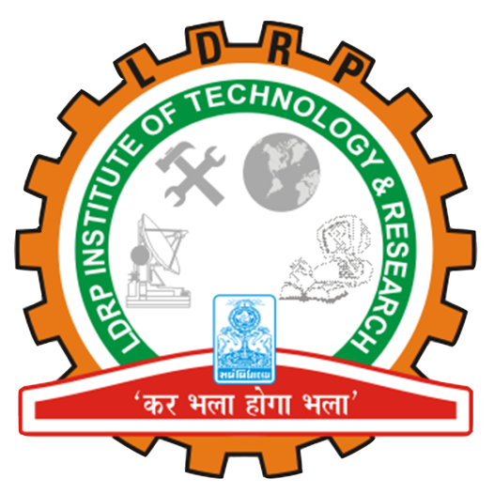

CERTIFICATE
This is to certify that the Project Work entitled “Arduino Based Hand Gesture Control For Computer” has been carried out by Yash Patel(1721BECE30228) under my guidance in fulfilment of the degree of Bachelor of Engineering in Computer Engineering Semester-6 of Kadi Sarva Vishwavidyalaya University during the academic year 2019-20.

Vaidehi Patel Ms. Shivangi Surati
Internal Guide Head of the Department

